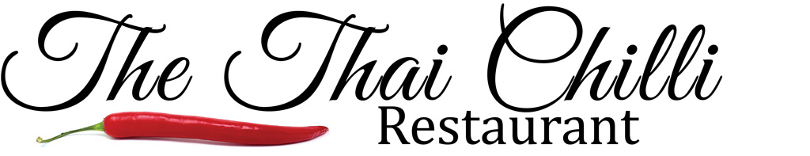

Chef Special Signature Dishes
DUCK SPRING ROLLS WITH HOISIN SAUCE (starter) £9
JUMBO PRAWN PARADISE (Goong Makham)
Tiger Prawns exotic tamarin sauce cashew nuts, deep fried shallots and coriander (Mild) £22
SPICY SEAFOOD DELIGHT (Phadcha Talay)
Mixed seafood with stir fried Tiger Prawns, fish, mussels & Squid served with Thai home made Pad Cha sauce (Spicy) £25
PLA NAMANOW
Sea-bass Steamed with Lime juice, lemongrass, Chinese Cabbage & home made Thai seafood chilli sauce (Medium spice) £22
PLA SAM ROD
Deep fried Sea bass, bell pepper, lemongrass with home made Sam Rod sauce £20
CHU CHEE
Chu Chee with either Jumbo Prawns or Deep fried sea Bass £22
LAMB SHANK MASSAMAN £18
All Signature dishes are served with steamed Jasmine Rice
PHAD KEY MOW TALAY
Stir fried flat noodles with spicy Thai herbs, grilled Tiger Prawns, fish, mussels & Squid £25
A discretionary 10% service charge will be added to your bill

